# Sequence Diagram:

Figure 12: UC1 & Major Sequence Diagram:

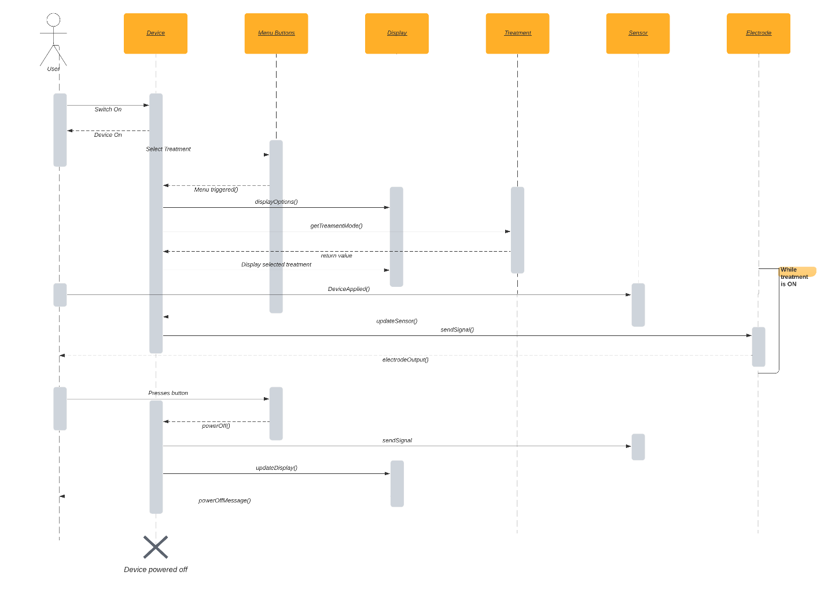

Figure 8: UC2 SD:

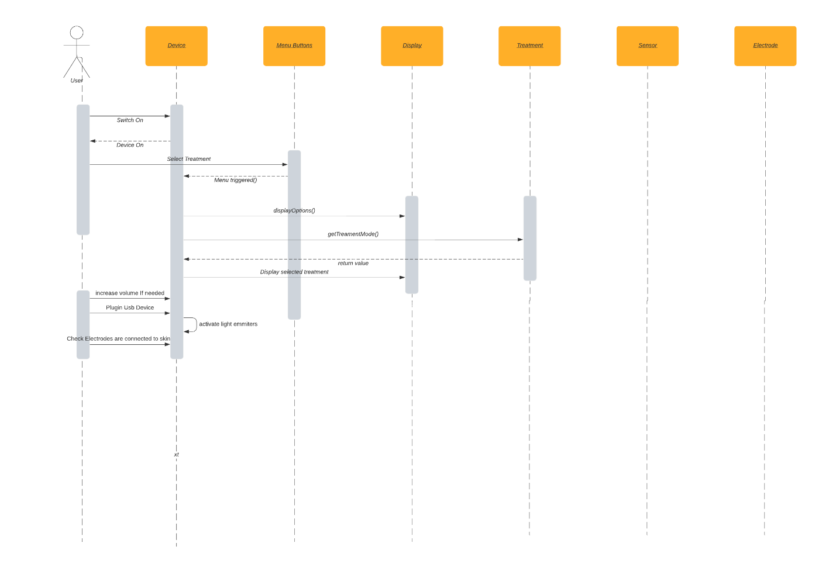

Figure 9: UC3 SD:

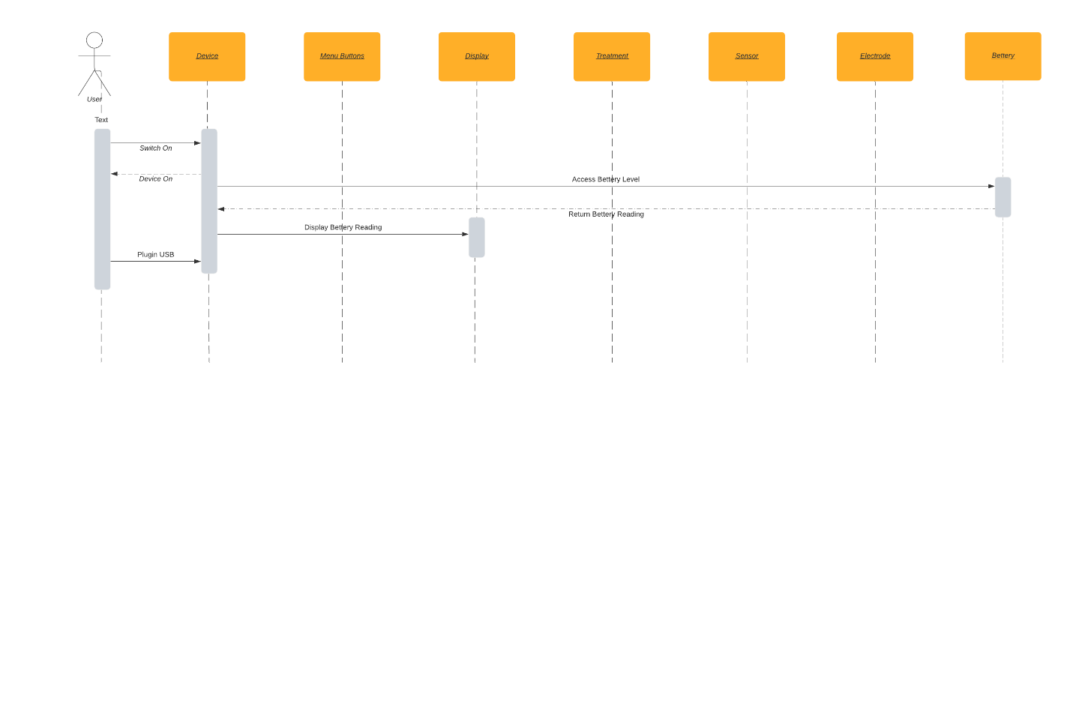

Figure 10: UC4 SD:

